MANUAL FOR HELIOCENTRIC UPGRADES

OF MAGISOFT

There are several Heliocentric Upgrades for the MagiSoft program. It is useful to understand what the general capabilities of each upgrade are before we go into the details. Below is an overview of each of the Heliocentric Upgrades.

Basic Heliocentric Upgrade

This upgrade enables the MagiSoft program to have the ability to provide heliocentric data and charts. None of the other heliocentric upgrades can operate without this upgrade. With this upgrade, your MagiSoft program can give you a Magi Astrology Chart for the same time periods that your MagiSoft program can create charts for in geocentric astrology. For example, if the geocentric capability of your program includes the year 1888, this upgrade can create the heliocentric charts for 1888 (which is the case if you are at least a second year member).

More importantly, when you have the Basic Heliocentric Upgrade, every calculation your MagiSoft program is capable of making for geocentric astrology is replicated in heliocentric astrology (except for Secondary Progressions calculations which requires the additional Heliocentric Progressions Upgrade that we will discuss later on in these instructions).

For example, with the Basic Heliocentric Upgrade, you can calculate transits to Heliocentric Charts (which are often the most crucial transits), plus heliocentric aspects for both the heliocentric longitudes and latitudes, as well as Magi Quads and Midpoint Crossings of Heliocentric Charts. The Basic Heliocentric Upgrade will also give you the time and date that an aspect or transit is most exact in the heliocentric dimension. You can even create a heliocentric CAC.

With the Basic Heliocentric Upgrade, everything you can do in geocentric astrology you can also do in heliocentric astrology (except that you need the Heliocentric Progressions and Interpretations Upgrades to obtain progressions and interpretations for heliocentric astrology).

If you have the MagiSoft asteroids upgrade, the Basic Heliocentric Upgrade enables your MagiSoft program to include the four major asteriods in all heliocentric charts and calculations.

Heliocentric Progressions Upgrade

You must have both the geocentric Progressions Upgrade plus the Basic Heliocentric Upgrade if you wish to install the Heliocentric Progressions Upgrade. The geocentric Progressions Upgrade calculates all the important forms of secondary progressions (Magi Progressions) but does so only in the geocentric longitudes and the declinations. When you also have the Heliocentric Progressions Upgrade, you will be able to perform the same calculations and obtain the equivalent data for the heliocentric longitudes and the latitudes, including listings of the exact calendar date and time when the important heliocentric progressions will peak. At this time, only the Magi Society's software has the ability to calculate heliocentric progressions. More often than not, the heliocentric progressions are more powerful than the geocentric progressions in matters of great significance.

Heliocentric Interpretations Upgrades

The MagiSoft geocentric Interpretation Upgrades provide you with accurate and reliable interpretations for transits and interaspects that occur in the geocentric dimension. The MagiSoft Heliocentric Interpretation Upgrades offer the heliocentric equivalent of these interpretations. There are four Interpretation Upgrades for geocentric astrology and there are four matching upgrades for heliocentric astrology. The Magi Society's research has discovered that heliocentric transits are often more important than those in the geocentric dimension. Yet no other software we are aware of provides you with interpretations for transits in matters of love or money that occur in the heliocentric dimension. If you have any of the MagiSoft's geocentric Interpretation Upgrades, you may add the matching Heliocentric Interpretation Upgrade that will provide equivalent interpretations for the heliocentric dimension.

Magi Astrology is remarkably consistent. For this reason, the principles of Magi Astrology work in the same way for both geocentric and heliocentric astrology. And the symbolisms of Magi Astrology are valid for both the heliocentric and geocentric dimensions. Therefore it should come as no surprise that the interpretations for heliocentric astrology are the same as those for geocentric astrology. But of course there are additional interpretations for Heliocentric Astrology since Heliocentric Magi Astrology has the Earth (what the Magi Society calls the Earth-Moon complex).

The research of the Magi Society discovered that the heliocentric transits to the Earth-Moon complex in the latitudes are the single most important type of astrological influence that has significant worldwide repercussions. If you have ever wondered what are the most important astrological influences that effect the entire world and everything in it, it is transits to the Earth-Moon complex in the latitudes because every thing that has a chart has the same transit. This is the basis of what we call UNIVERAL TRANSITS, as we will explain later in these instructions.

For now, we need to explain how to use each of the Heliocentric Upgrades.

How to Use the Basic Heliocentric Upgrade

Below is the screen display of the MagiSoft program when the Basic Heliocentric Upgrade is installed:

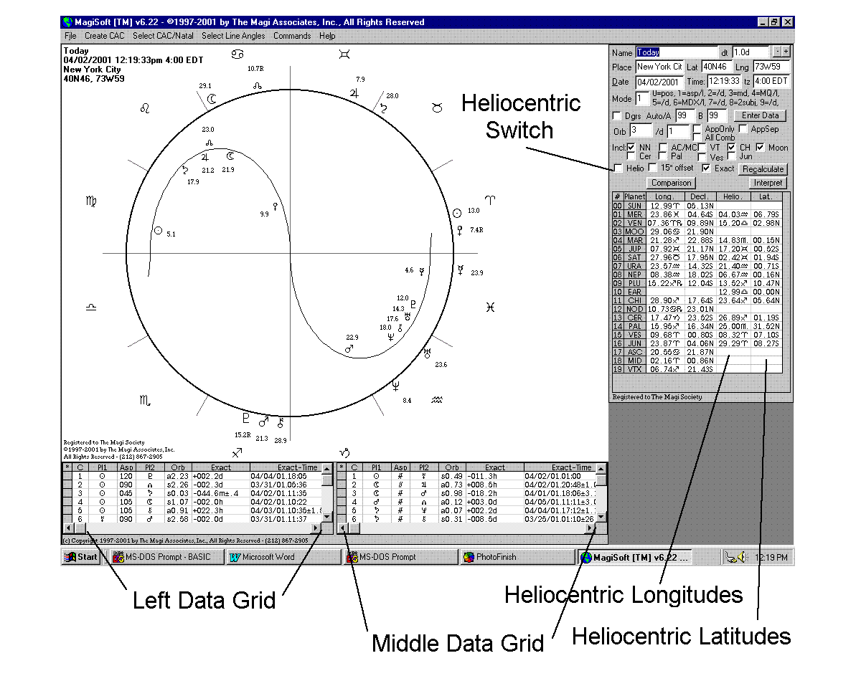

The MagiSoft program that does not have the Heliocentric Upgrade will have only two columns of data to the right of the Magi Astrology Chart. The first column gives you the longitudinal data and the second one gives the declinational data. With the Basic Heliocentric Upgrade installed, MagiSoft will display two additional columns of data in the Data Display Area and the two new columns contain the heliocentric data. One column contains the heliocentric longitudes and the other the latitudes.

The MagiSoft Basic Heliocentric Upgrade is fully integrated into the MagiSoft program so that it is "seamless" and therefore Magisoft is very easy to use. Whatever calculation you make in geocentric astrology, you get the heliocentric equivalent just by switching to the Heliocentric Level.

You can instruct your MagiSoft program to enter the Heliocentric Level simply by selecting the COMMANDS/INTERPRET MENU, and clicking on the choice labeled HELIOCENTRIC/GEO. To go back to the geocentric level, you repeat these same steps. (You can also simply click on the Heliocentric Switch box that is highlighted in the illustration above. Whenever you click on that box, the MagiSoft program will switch back and forth from geocentric to heliocentric or vice versa.)

For example, if you want MagiSoft to calculate the aspects of a day in geocentric astrology, all you do is go to mode 1 by entering [ <Alt> + < 1 > ] (or use the Data Modes menu). This will tell MagiSoft to calculate all the aspects and display the data in the Left and Middle Data Grids. If you now want to instruct MagiSoft to enter the Heliocentric Level and calculate and display the data that are the heliocentric equivalents (the aspects in the heliocentric dimension), all you have to do is click on the Heliocentric Switch box (or use the Commands/Interpret Menu and select Heliocentric/Geo). Once you do this, the MagiSoft program will display the heliocentric Magi Astrology Chart in its graphics area, and the heliocentric data for the aspects will be displayed in the Left and Middle Grid. To go back to displaying the geocentric data, just repeat the same steps you used to go from geocentric to heliocentric.

Every principle of Magi Astrology works just as well in heliocentric astrology. Therefore we designed the Basic Heliocentric Upgrade so that everything you can do in geocentric astrology with the standard MagiSoft program, you can also do in heliocentric astrology with the Basic Heliocentric Upgrade (except progressions and interpretations that require the other heliocentric upgrades).

As you know, there are 12 data modes for your MagiSoft program and you can select any of them by using the Data Modes menu or the corresponding Alt Keys. All 12 data modes work in the Heliocentric Dimension. Each of the 12 data modes works in exactly the same way for both the geocentric and heliocentric levels. When you enter the Heliocentric Level, below is a listing of the 12 data modes and what they do in the heliocentric level:

Mode 0: lists heliocentric planetary positions in the Left Data Grid; both the longitudes and latitudes are listed; the Middle Data Grid will be blank;
Mode 1: lists interplanetary aspects in the heliocentric longitudes in the Left Data Grid, and interplanetary aspects in the latitudes in the Middle Data Grid;
Mode 2: lists the same interplanetary aspects as mode 1 but reverses the areas in which they are displayed; the Left Data Grid will have the latitudes and the Middle Data Grid will have the heliocentric longitudes; the reason you may use this is that the <page up> and <page down> keys only work in the Left Data Grid;
Mode 3: lists all the heliocentric midpoints in the Left Data Grid and the Middle Data Grid is blank;
Mode 4: lists longitudinal Magi Quads in the Left Data Grid, and latitudinal Magi Quads in the Middle Data Grid;
Mode 5: lists MQs, as in mode 4, but in reverse Scroll Areas;
Mode 6: lists heliocentric longitudinal Midpoint Crossings in the Left Data Grid and latitudinal ones in the Middle Data Grid;
Mode 7: lists Midpoint Crossings, as in mode 6, but in reverse Scroll Areas;
Mode 8: is used to calculate interaspects and transits that occur in the heliocentric charts; with the longitudes in the Left Data Grid and the latitudes in the Middle Data Grid;
Mode 9: is also used to calculate transits/interaspects in the heliocentric charts, but displays them in reverse in the Scroll Areas.
Mode 10: is also used to calculate transits and interaspects by midpoints in the heliocentric charts, with the longitudes in the Left Data Grid and the latitudes in the Middle Data Grid. TO GO TO THIS MODE, ENTER [<Alt> + <A>}
Mode 11: same as mode 10 but reverses the order in which the midpoint transits are displayed. TO GO TO THIS MODE, ENTER [<Alt> + <B>].

You can go into Full Screen Mode when you are in the Heliocentric Level and MagiSoft will display the heliocentric chart that is the size of the full screen. But when you are in the Full Screen Mode, you cannot switch back and forth between the heliocentric level and the geocentric level. You can only do that while you are in the Main Screen.

WHAT DOES THE EARTH REPRESENT IN HELIOCENTRIC ASTROLOGY?

Almost all astrologers who employ heliocentric astrology do not give any real weight to the Earth and disregard it in their analysis. However, as a result of the research of the Magi Society, it is very clear that the Earth has awesome significance. Here is what the Magi Society has learned:

The position of the Earth in the heliocentric chart represents the position of both the Earth and the Moon. For this reason, the heliocentric position of the Earth is twice as important as that of any of the planets because the position of the Earth really represents the position of the Earth/Moon complex. This is the case for both the heliocentric longitudes and latitudes.

The position of the Earth/Moon complex is always zero degrees latitude. This means everyone and every entity has the same location for their Earth/Moon complex in the latitudes. Astrologers have concluded from this fact that the Earth/Moon position in the latitudes has no meaning. But the opposite is true. The fact is that it was Divinely Designed that everyone's Earth/Moon complex is the same in the latitudes and this fact forms the basis of what the Magi Society calls the UNIVERSAL TRANSIT.

THE UNIVERSAL TRANSIT

The position of the Earth/Moon complex is always zero degrees of latitudes in heliocentric astrology. Everything and everyone has the same position for their Earth/Moon complex in the latitudes. THIS MEANS WE ARE ALL IN THE SAME BOAT and when there is a transit to one person's Earth/Moon in the latitudes, the same transit is in place for everyone and everything on Earth. Every animal, every corporation, every country, every marriage, everything and every person all have the same location for their Earth/Moon complex in the latitudes. THIS IS THE AMAZING ASTROLOGICAL REASON THAT ALL OF US ON EARTH HAVE LINKED DESTINIES. For this reason, we refer to any transit to the Earth/Moon complex in the latitudes as a UNIVERSAL TRANSIT.

Whenever there is a significant Universal transit, there are worldwide repercussions. Here are some "recent" examples of the awesome power of a Universal Transit:

A: For example, when Saddam Insane ordered the Iraqi armed forces to invade Kuwait on August 2, 1990, Saturn was making an applying parallel and was within 0.04 degrees of the Earth/Moon complex in the latitudes. This meant Saturn was transiting everyone's Earth/Moon complex! This transit peaked when Saturn was exact on September 3, 1990, about one week from the low in the US and worldwide bond markets.

B: For example, when the Berlin Wall opened on November 4, 1989 and Poland, East Germany, Romania, etc. toppled their communist dictators, Jupiter was making a Universal Transit to everyone's Earth/Moon complex. It was parallel to all of our Earth/Moon complexes in the latitudes.

C: For example, when Japan attacked Pearl Harbor on December 7, 1941, Mars (ruler of war and attack by force) was within 0.1 degrees of the Earth/Moon complex in the latitudes. The actual transiting parallel separated a few days before, which coincided with the fact the actual orders to attack were given before the Japanese planes arrived over Pearl Harbor. But on the day of the attack, the midpoint of Mars-Uranus was making a Universal Transit and was applying and within 0.1 degrees of exactness of the zero degree position in the latitudes. This is another example of Magi Astrology working perfectly since Uranus rules flying and Mars rules war, thus combining for a "flying war" for that day.

D: For example, on October 19, 1987, when the stock market had its worst single day crash in history, there was a Nuclear Clash formed in the latitudes of the heliocentric sky. Although the formation of the clash in the sky is certainly an indication of possible pain, the real astrological problem was that this clash meant that the Jupiter-Saturn midpoint was making a Nuclear Clash Transit to everyone's Earth/Moon complex in the latitudes. To make matters even worse, this was a very long lasting transit. The Universal Transit by Jupiter-Saturn was applying until January 18, 1988, about 90 days later. Amazingly, the US stock market stayed low until just about January 18, 1988. It was this Universal Transit that was the main astrological reason every stock market around the whole world crashed during this transit.

Once again, by being a member of the Magi Society, you have now acquired valuable astrological knowledge as a result of your membership.

ALL 12 MODES WORK IN HELIOCENTRIC ASTROLOGY

As we already explained, when you have the Basic Heliocentric Upgrade, your MagiSoft program will display the data calculated by the 12 modes in either geocentric form or heliocentric form. You can have one or the other, depending on whether you instruct the MagiSoft program to be in the geocentric or heliocentric level. But it will not display the data calculated by the 12 modes in both geocentric and heliocentric levels at the same time. You have to switch back and forth. You may use your printer and print one set of data and then the other to see them together.

However, the MagiSoft program will display both the geocentric and heliocentric Magi Astrology Charts at the same time. You can do this by using the DUO MODE.

DUO MODE

It is very useful to be able to visually analyze both the geocentric and heliocentric Magi Astrology Charts at the same time. For example, if you are looking for a good astrological day to begin something very important, you would want to find a day with Super Aspects in both the geocentric and heliocentric charts. And you would want to select a day that avoids bad aspects in either dimension.

With the Basic Heliocentric Upgrade, MagiSoft can display both the geocentric and heliocentric charts at the same time and you can do this by using the Duo Mode. To go to the Duo Mode, simply enter the hotkey combination of [ < Alt > + < H > ]. (This means you press the Alt key and hold down the H key.) By doing this, you will be instructing the MagiSoft Basic Heliocentric Upgrade to enter Duo Mode and display the geocentric and heliocentric Magi Astrology charts at the same time, side by side.

Once you are in the Duo Mode, you can instruct MagiSoft to draw lines for only certain types of aspect lines so you can easily see them in both charts at the same time. You can do this by using the Select Line Angles Menu, or using the F5 through F12 function keys. For example, for April 5, 2001, the Duo Mode would display the charts below when you screen for linkages and semi-linkages (either by selecting that choice from the Select Line Angles Menu or by pressing F10).

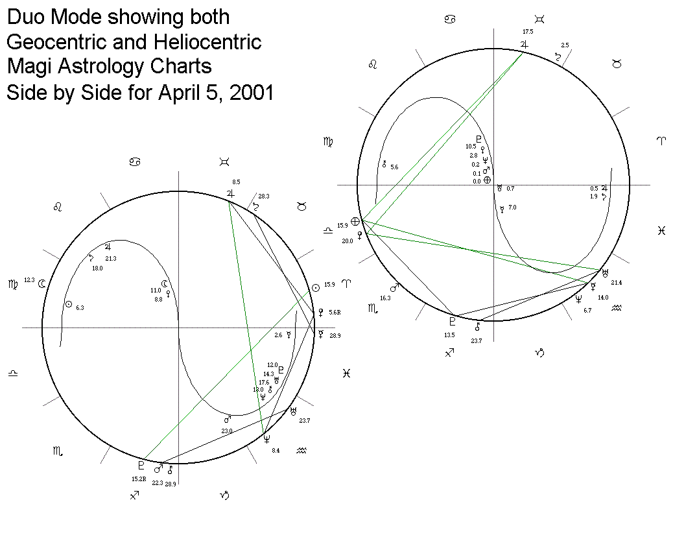
When you are in the Duo Mode, the MagiSoft program displays the heliocentric chart on the right and the geocentric chart on the left.

When you are in the Duo Mode, you can also scan ahead or backwards in time to look for good days. Let's demonstrate how this works and how useful this is.

Please create the geocentric chart for April 5, 2001 at noon in time zone + 4. Now go to the Duo Mode by entering [ < Alt > + < H > ]. Now press the F10 function key (or do the same thing by using the Select Line Angles Menu and choosing Linkages and Semi-linkages). Your computer screen should display two charts very much like the ones above. (Your charts will probably look a little different because your settings are probably different from ours. For example, we turn off the AC/MC, NN, VT and the asteroids.)

Now you can scan ahead for days with good aspects by holding down the Control Key and pressing the Right Arrow key. If you do this once, you will see that the date of the charts shown will advance by one day and there was a Grand Trine in the heliocentric dimension on April 6 of 2001. As you continue to hold down the Control Key and press the Right Arrow key, you will see the Grand Trine pass and dissipate. If you want to go backwards in time, hold down the Control Key and press the Left Arrow Key.

(You may want to refer to the Time Increment segment, as well as the segment entitled Special Features for Financial and Electional Astrology that are in your User's Guide for MagiSoft v. 6.22. This document is on your CD.)

You cannot create a CAC while in Duo Mode. It would be very useful to be able to do so and we will work on this for the future. When we originally designed the Duo Mode feature some time ago, the size of the average computer screens was much smaller than they are now and did not allow enough space to fit two CACs with the details clearly visible on just one screen. But now screens are much larger.

The best way to examine CACs is to create one in geocentric, and then just go to the Heliocentric Level to see the CAC that is formed in that dimension. If you really want to see both of them at the same time, and you own Microsoft Word, you can do so by following these steps:

First create your CAC in geocentric, then go to Full Screen Mode ( [ < Crtl > + < G > ] ) and remove the extra data grid by entering [ < Ctrl > + < A > ] so that you see only the full screen CAC. Now take a "screenshot" of this CAC by pressing the Print Screen Key (usually located on the top row of your keyboard), and then go back to the Main Screen by entering [ < Ctrl > + < G > ] again. If you have Microsoft Word, open Word and create a new document. (You can also use another Word Processor.) Next paste in the screenshot of the CAC onto the new Word document by entering [ < Ctrl > + < V > ]. Your CAC will appear on your Word page. Next go back to MagiSoft and instruct MagiSoft to create the CAC in heliocentric astrology by using the Commands/Interpret Menu and selecting Heliocentric/Geo. The CAC will now be the heliocentric CAC. Our next step is to take a "screenshot" of this CAC and also paste that into the Word document. To do this, go to Full Screen Mode ( [ < Crtl > + < G > ] ) and remove the extra data grid by entering [ < Ctrl > + < A > ] so that you see only the full screen CAC. Take a "screenshot" of the heliocentric CAC by pressing the Print Screen Key. Go back to Word and paste in the screenshot of the heliocentric CAC by entering [ < Ctrl > + < V > ]. Now you have both the geocentric and heliocentric CACs on a single Word document that you can print. YOU CAN NOW EMAIL THIS WORD DOCUMENT AS AN ATTACHMENT TO ANYONE IN THE WORLD. We suggest you first resize these two CACs so they both fit on just one page. You can resize a CAC in Word by clicking on it (a rectangular outline will appear), and then move the arrow of your pointer around the lower left corner until you see resizing arrows appear (the ones that point diagonally in both directions). When the resizing arrows appear, click the left mouse button and move the mouse pointer upwards and to the right until you get the size you want. Repeat for the other CAC. When both CACs are the same size and fit onto one page, you can print something that is of enormous value: a "side by side" pair of CACs for geocentric and heliocentric astrology. Such charts are destined to change all of astrology!

ORBS TO USE IN HELIOCENTRIC ASTROLOGY

Which brings us to the subject of the proper orb for latitudes and heliocentric longitudes. (Latitudes are the heliocentric equivalent of the declinations.) It should be obvious that the orb of 3 degrees applies to the heliocentric longitudes for transits, aspects and interaspects. As for the latitudes, the Magi Society normally uses an orb of just 0.3 degree but for slow moving planets, we sometimes tighten to 0.2 degrees or even 0.1 degrees. We will discuss this more in lessons that will be posted on our Members Only Site.

Heliocentric Progressions Upgrade

If you own the geocentric Progressions Upgrade, then you would qualify to be able to purchase the Heliocentric Progressions Upgrade. By adding this upgrade, you can calculate the equivalent heliocentric progressions for every progression you can calculate in geocentric astrology. If you bought both progressions upgrades, when you install MagiSoft v. 6.22, your installation CD automatically installs these upgrades for you.

Anything you can do in geocentric astrology with the Progressions Upgrade, you can also do in heliocentric astrology when you also have the Basic Heliocentric Upgrade plus the Heliocentric Progressions Upgrade. In addition, you have the ability to enter the Duo Mode so that you can view side by side the progressed charts in both geocentric and heliocentric astrology.

To obtain a heliocentric progressed chart, you should first calculate the geocentric progressed chart using the exact same procedures detailed in our Progressions Manual. Once you have the geocentric progressed chart displayed, you can create the equivalent heliocentric progressed chart easily by instructing MagiSoft to enter the heliocentric mode, which you do just by using the Commands/Interpret Menus and clicking on Heliocentric.Geo (or click the Helio Box located on the Main Screen). You can go back to the geocentric chart by repeating the process and you can switch back and forth as many times as you want.

Magi Astrology is consistent so all of Magi Astrology's principles of geocentric progressions are valid and applicable in the heliocentric dimension. Very often, the secret of understanding a momentous trend is in the Magi Astrology Progressions that occur in the heliocentric dimension.

For example, the astrological signs for the historic and unprecedented boom and bust of the technology stocks in the last five years are found in the heliocentric progressions of the United States.

To begin, we would like to remind our members that we explained in all of our writings that the most crucial step forward in understanding what is happening is to know what astrological charts to look at. For example, in our lessons for members, we pointed out the importance of the real birth chart of the USSR and how it pinpoints why the Soviet Union was an authoritarian country with a powerful army and was widely regarded as the Cinderella of communist countries.

From our vast experience, we have discovered that the most crucial astrological chart for predicting the economy of the United States is the natal chart of the US. As we have repeatedly explained, the strongest astrological influences on a chart are the Magi Astrology Progressions of that chart.

Although some astrologers are still in denial of the truth, there is simply no question that the chart of the USA is that of July 4, 1776. (The time is uncertain but we will use noon to conform with our normal standards when there is no exact time available.) Let us calculate the progressions for January 14, 2000, the day the Dow Jones Industrial Average made its all time high. We should do this first in the geocentric dimension and then also in the heliocentric dimension. To accomplish this, please create a chart for July 4, 1776 at noon for time zone + 4. (Those of you who are third year members will be able to do this; otherwise your ephemeris will not go back that far.) Now go to mode 0 and then open the Progressions Window by entering [ < Ctrl > + < P > ] and enter the date of January 14, 2000 into the Progressions Window. Then click the Update Button in the Progressions Window. Now enter [ < Alt > + < 1 > ] to calculate the Progressed Aspects. As you can see, there are a lot of progressed aspects but none are that interesting. However, if we calculate the progressed aspects in the declinations (do this by entering [ <Alt> + < 2 >], you now see that there was a Financial Super Progression of Venus parallel Neptune that peaked around Dec. 29, 1998. The actual date this progression peaked can be plus or minus 6 months since we are using noon as the birth time, and the actual birth of the US could have been up to 12 hours earlier or later (which equates to 6 months in the progressions).

What is interesting about the Dec. 29, 1998 peak of the progression is that the US bond market actually set a record just about 10 weeks earlier when the yield on the "long bond" fell to a record low since they issued such bonds. About a year later, the US government actually had enough of a surplus to begin buying back some of its bonds. This makes perfect sense because the Venus-Neptune Financial Super Progression helps the native make money. In this case the native is the US. THIS IS THE PROGRESSION that was most responsible for the great economy of the mid-to-late 1990s in the US.

Now let us calculate the Magi Astrology Progressions in the heliocentric dimension. To do this, all you have to do is click the Heliocentric Switch box or use the Commands/Interpret Menu and select Heliocentric/Geo. When you do this, whichever one of the 12 modes you are in, you will remain in the same mode but you will switch to the heliocentric dimension and all the data in the Progressions Window will change from geocentric to heliocentric. The chart that the MagiSoft program displays will also be the progressed heliocentric chart for the US for January 14, 2000.

Now please focus your attention on the area of zero degrees in the latitudes. You can easily see that there was a triple parallel of Earth, Venus and Uranus that was formed in the latitudes of this progressed heliocentric chart for the US on January 14, 2000. This triple parallel includes the Silver Progression of Uranus parallel Venus. We have categorized this progression as a Silver Progression rather than a Golden Progression. But we have explained that when it comes to areas ruled by Uranus, this progression is actually golden. Among other things, Uranus rules technology, broadcasting, cellular phones and the Internet. This would mean that during the period of time when the Venus/Uranus progression was applying, the US as a country was attracted to (Venus) and fell in love with technology (Uranus), the Internet (Uranus) and broadcasting and cell phones (all Uranus). This translates into the technology stock craze that was unprecedented. But it is important to understand that the Venus/Uranus progression by itself would not have had the strong effect it seemed to have. It was actually the combination of the geocentric Venus/Neptune progression plus the heliocentric Uranus/Venus/Earth progressed triple parallel that created the environment necessary for the unprecedented boom in technology stocks. Now these progressions are gone and so is the boom.

Below is the heliocentric progressed chart for the US on January 14, 2000, using noon.
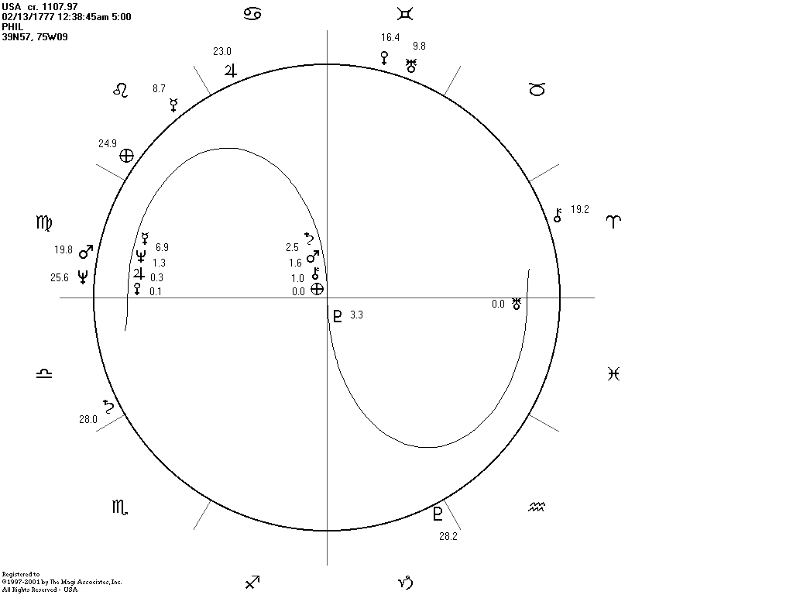

It is easy for you to see that the most significant astrological influence in this chart was the very tight triple parallel of Venus, Earth, and Uranus.

Of course we wish to repeat what we have stressed in our prior manuals and all of our books:

ALWAYS ANAYLZE THE LINKED CHARTS

When you are trying to decide on a forecast of a major trend, you have to always take into account what is happening to all of the LINKED CHARTS. Linked Charts are natal charts of entities whose destinies are necessarily similar in some important ways. For example, the destiny of the US economy must be closely connected to the destinies of America's most successful corporations. You must therefore analyze the charts of these companies plus the US chart together and you should never rely on any single astrological indicator all by itself. When something historic is going to happen to the US economy and stock market, the chart of the US and the charts of America's most important companies must have similar progressions. This was exactly the case with the technology stock boom and bust. It is certainly true that the peak of the Venus/Neptune and Venus/Uranus/Earth progressions in the US natal chart were very significant. But there were also CONFIRMING SIGNS in the charts of America's corporate leaders. It turns out that there were very precise confirming signs of the boom and bust of the technology stocks and we informed you about some of these signs in Lesson Five of the Members Only Website. We revealed in that lesson that America's four most successful technology-based companies all had Super Financial Progressions that peaked around the same time. Intel, Microsoft, Oracle and Cisco all had Financial Super Progressions that had peaked in 1999-2000. This fact very strongly confirmed the peak of the Financial Super Progressions in the US chart. In a very real sense, those US progressions were linked with those of the US corporate leaders. Their progressions seem to be tied together and coordinated. It is amazing but it seems astrology looks ahead and somehow connects every major piece together with linked destinies.

[Note for those of you who are very oriented about details: When we designed and wrote the MagiSoft program's algorithms for the calculation of parallels and contra-parallels, we formulated them such that we did not list both a parallel and a contra-parallel between two planets at the same time. For example, when Venus and Uranus are within orb of forming both a parallel and a contra-parallel, which can happen when both planets are close to the zero degree line, then the MagiSoft program lists only the aspect that is closest in orb. Our theory for doing it this way is based on our belief that the two planets can form only one aspect as opposed to two of them. Therefore, if someone is born with Venus and Uranus within orb of both a parallel and a contra-parallel, we view that person as having one, but not two, Super Aspects formed by Venus-Uranus. When we added the Progressions Upgrade, we simply used the same algorithms for calculating progressed aspects and we believe that only the tighter progressed aspect is active, not both of them. The same theory applies in that you can only have one progressed aspect formed by any two planets. Only the more exact progressed aspect is in effect while the less exact progressed aspect is not. However, it can be useful to have a list of both of the progressed aspects so we can easily see when each has peaked. We will add this to a future version of our program.]

Interpretation Upgrades for Heliocentric Astrology

There are four Interpretation Upgrades for geocentric astrology. If you own the geocentric Interpretation Upgrade, you may purchase the corresponding Heliocentric Interpretation Upgrade.

If you own any geocentric Interpretation Upgrade, and you have purchased the Basic Heliocentric Upgrade but you chose to not buy the corresponding Heliocentric Interpretation Upgrade, then your existing Interpretation Upgrades will not work when you are in the Heliocentric Level. Your upgrades will of course continue to work in the geocentric dimension. In other words, if you did not order heliocentric interpretation upgrades, even if you have geocentric interpretation upgrades, your MagiSoft program will not be able to open the Interpretation Window when it is in heliocentric mode.

Just as there are four Interpretation Upgrades for geocentric astrology, there are also four interpretation upgrades for heliocentric astrology. If you bought any combination of Heliocentric Interpretation Upgrade(s), when you installed MagiSoft v. 6.22, your installation CD automatically installed these upgrades for you.

The Heliocentric Interpretation Upgrades work in all ways exactly the same as the geocentric Interpretation Upgrades do. There is not a single difference.

HOW TO LOAD THE HELIOCENTRIC INTERPRETATION OF YOUR CHOICE:

As most members know, the Magi Society offers four categories of Interpretation Upgrades. These four are:

Upgrade #1: Romance interpretations for important interaspects
Upgrade #2: Career and money interpretations for important interaspects
Upgrade #3: Romance interpretations for important transits
Upgrade #4: Career and money interpretations for important transits

There are also four heliocentric interpretation upgrades that correspond to each of the above four categories. If you ordered any of the heliocentric interpretation upgrades, these upgrades work for both the geocentric and heliocentric modes. For example, Upgrade #1 would give you romance interpretations for important interaspects in both geocentric and heliocentric modes. Upgrade # 2 would give you the career and money interpretations for important interaspects.

As explained in Part Two of the User's Guide for MagiSoft v. 6.22, you have to load an interpretation file to be able to access the interpretations. To instruct the MagiSoft program which interpretation file to load, you have to follow these steps precisely:

1) First you must select the Commands/Interpret Menu
2) Next you need to click on Load Interpretations and a sub-menu will appear to the right side
3) Finally please click on one of the four choices

The illustration below shows you the MagiSoft screen when you follow each of the above steps:

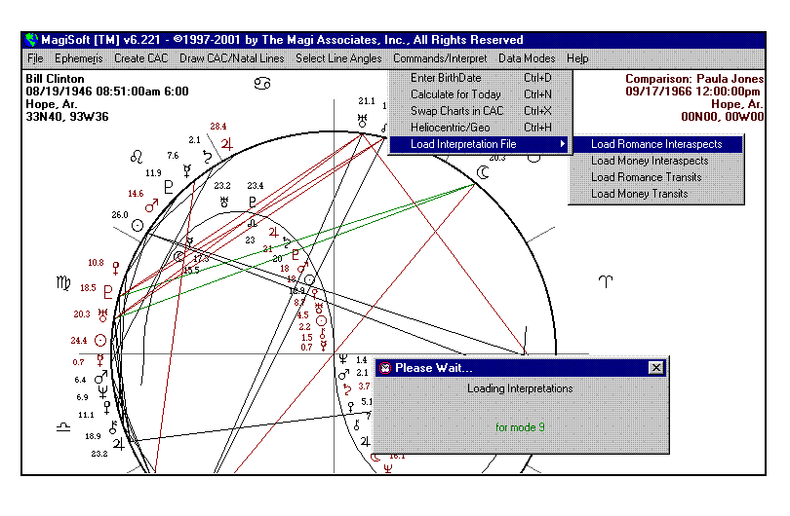

The above is the case for both geocentric and heliocentric upgrades.

If your Interpretation Window is open, whenever you switch back and forth from geocentric to heliocentric modes, your Interpretation Window will close. If you ordered heliocentric interpretations, you will be able to reopen your Interpretation Window and it will work as normal. If you did not order heliocentric interpretations, then you will not be able to open the Interpretation Window when you are in heliocentric mode.

We should explain that the effective orb for interaspects and transits in the heliocentric longitudes is still 3 degrees but for the latitudes, it is 0.30 degrees. The latitudes is the heliocentric equivalent of the declinations. Unfortunately, you can only enter one orb for the declinations and latitudes since the box for the orb of declinations is also the box for the orb of the latitudes. We suggest when you are ready to print the interpretations, you set the orb for latitudes to just 0.3 degrees so only the effective interaspects and transits in the latitudes will be printed. If you print interpretations for latitudes using an orb of 1 degree, you will get an enormous number of interpretations and most of them are not valid since the effective orb is just 0.3 degrees.

REMINDER: YOU MUST LOAD AN INTERPRETATION FILE

BEFORE YOU ATTEMPT TO USE ANY OF THE INTERPRETATION FEATURES

As is the case with the Geocentric Interpretations Upgrades, you should FIRST load one of the interpretation files before attempting to use the Interpretation Feature of your heliocentric upgrades. To repeat, you can load an interpretation file by clicking on the Commands/Interpret Menu, selecting Load Interpretations, and clicking on the interpretation file you wish to load.). When you actually choose one of the interpretations files, the MagiSoft program will display a message box that it is loading interpretations.
If you do not first load an interpretations file, and you still attempt to use some of the interpretations features like the ones we describe below, you will get an error message asking you to load an interpretations file. If you deviate from these instructions, depending on exactly what mistakes you might make, it is even possible for the MagiSoft program to freeze on you, in which case you have to enter the three keys [<Ctrl> + <Alt> + <Del>] all at the same time. This would allow you to close the MagiSoft program and then reload MagiSoft. There is no need to worry if this happens to you; it does not hurt the program or any of your files.

In order to load your geocentric Interpretations Upgrades, you had to use the Commands/Interpret Menu and you have to do the same with your Heliocentric Interpretation Upgrades. Since the symbolisms of Magi Astrology are consistent and work for both geocentric and heliocentric astrology, the Heliocentric Interpretation Upgrades are just a revised edition of your geocentric upgrades. But of course the heliocentric upgrades have interpretations and ratings for interaspects and transits involving the Earth/Moon complex, and the geocentric ones do not. Since the Earth/Moon complex consists of two planets, such transits and interaspects are the most important interaspects and transits. Therefore, their ratings will reflect this fact. You now can have ratings in excess of +200, and lower than -200. As with all of our interpretations, we have copyrighted the interpretation text for Heliocentric Magi Astrology and believe they will greatly improve your abilities to interpret what is happening in your life and the lives of everyone whose birth data you know.

The Magi Society will continually update and improve all of our interpretation texts. Depending on the depth of any revisions, for each year or two that you remain a member of the Magi Soicety, you will receive an updated set of interpretation texts for every interpretation upgrade that you own. In this way you will always have the benefit of the new knowledge we gain.

Rv. 520.01 5pm

